**Group Name: Neophytes**

**Project: Online Grocery System**

**A textual description of the domain:**

The online grocery system allows the users to purchase the items online and get it delivered at their door-steps. Depending upon the total bill, there may or may not be delivery charges associated with this type of service. Our system allows the user to purchase items listed under various categories. The system allows the user a flexibility while making a payment, there are two payment methods, Card payments and Cash on Delivery. The basic flow of the events associated with the online grocery system are stepped below:

1. The user access the online grocery store using internet.

2. The user fills up the contact information form by providing the details including name, address, phone number etc. The online grocery stores only deliver to specific areas in its vicinity based on the postal code provided by the user.

3. Once the user fills up the contact information form, the system directs the user to the categories of items. The categories include fruits and vegetables, meats and fishery, Dairy products etc.

4. The user can select any category which contains a list of items with the price and any available offer. The user can select any items and quantity of the item he/she wish to order.

5. After selecting the items user can add the items to the cart.

6. When the user is done with selecting the items, he can place the order and is forwarded to the payment options page.

7. On the payment page user can select from two options either payment by card or cash on delivery. In both the options the delivery charges may be added to the final amount if the delivery address is more than 5km of the range. The maximum area that is covered for home delivery will be 10km. Acceding this limit may prompt user to choose alternate delivery address or pick up the items from the store itself.

8. User can make payment by Credit or Debit card or Cash on Delivery then, the user screen will be prompted with the message “Order has been placed” along with the estimated delivery time.

9. If the user is doing payment by Credit or Debit card and the payment is not processed, he will be transfer to Payment options page again to repeat the process until the payment is made successfully.

10. System Admin can View Registered Users, Modify Departments, Modify items and view History.

Following these above steps will ensure safe and easy way for the customers to take advantage of Online grocery system**.** People with hectic schedule or who are unable to carry grocery due to whether or some other reasons will get an added advantage of home delivery.

**Use Case Diagram of the Online Grocery System**

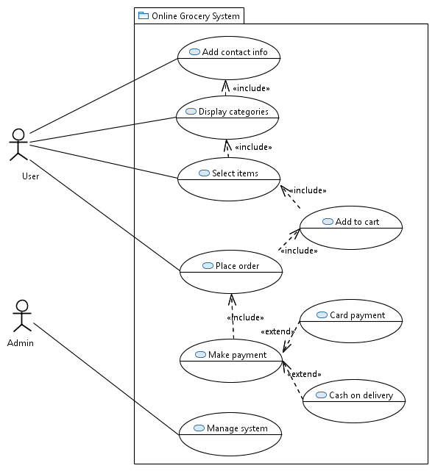

*Fig 1 Use Case Diagram of the System*

**Description of Use Cases for the Online Grocery System**

**Add Contact Information**

|  |  |
| --- | --- |
| **ID and Name** | UC-1 Add Contact Information |
| **Actors** | User |
| **Description** | The use case starts when the user lands on the homepage of the Online Grocery System. The systems displays a form requesting the user information such as name, address, postal code, phone number and email address. The form also lists the valid postal codes and valid timings for the delivery. |
| **Trigger** | User accesses the homepage of the Online Grocery System. |
| **Preconditions** | PRE-1 User is required to have an active internet connection with anyone of the latest web browsers installed in the system.  PRE-2 User must know the web address of the Online Grocery System. |
| **Post conditions** | POST-1. After the user fill the information, a menu with different categories is displayed.  POST-2. Incomplete user information prompts the user to re-enter the information. |
| **Normal Flow** | 1. User access the homepage of the Online Grocery System.  2. System requests the user to fill the complete contact information.  3. User enters the contact information and press ‘Submit’ button.  4. Successful submission of the information displays the categories to the user. |
| **Alternative Flow** | AF1. In step 2 of the normal flow, if the user enters an invalid postal code in the contact information, the system displays a message “Sorry, delivery at this place is currently unavailable.”  AF2. In step 3 of the normal flow, if the user submits the incomplete contact information then the system redirects user to the step 2. |
| **Priority** | High |

Table 2: Add Contact Information

**Display categories**

|  |  |
| --- | --- |
| **ID and Name** | UC-2 Display Categories |
| **Actors** | User |
| **Description** | The categories of the grocery are displayed to the user on successful contact information submission. Each category contains specific items. |
| **Trigger** | Successful submission of the contact information. |
| **Preconditions** | User must have filled the contact information. |
| **Post conditions** | List of items must be displayed on the screen |
| **Normal Flow** | 1. System displays all the categories of the items to the user.  2. User can select any category.  3. User can see the list of only the available items along with price/quantity or price/unit and available offer. |
| **Alternative Flow** | AF1. After step 2 of the normal flow, user can press ‘Back’ button to change the category and the system redirects user to step 1. |
| **Priority** | High |

Table 3: Display Categories

**Select Items**

|  |  |
| --- | --- |
| **ID and Name** | UC-3 Select Items |
| **Actors** | User |
| **Description** | The use case begins when the user select the item. The user can select one or multiple items and can mention the quantity or number of units the user wish to purchase. |
| **Trigger** | User selection of the item. |
| **Preconditions** | User must have selected a category. |
| **Post conditions** | User’s items must be selected successfully. |
| **Normal Flow** | 1. User selects the item.  2. User mentions the quantity or unit of the item. |
| **Alternative Flow** | AF1. User can de-select any item or can alter the quantity or number of units.  AF2. If in the step 2, the user mentions more than the quantity or the number of units available, then the system prompts the appropriate message to the user. |
| **Priority** | High |

Table 4: Select Items

**Add to cart**

|  |  |
| --- | --- |
| **ID and Name** | UC-4 Add to cart |
| **Actors** | User |
| **Description** | User can add selected items to the cart and the cart displays the total bill before taxes. |
| **Trigger** | Click “Add to cart” icon on the screen. |
| **Preconditions** | User must select the items. |
| **Post conditions** | User can see selected items with total amount before taxes. |
| **Normal Flow** | 1. User adds to the cart all the selected items.  2. User can see the items with total amount |
| **Alternative Flow** | AF1. User can remove items from the cart and the system directs the user to step 2 of the Normal flow with updated list of items and updated total amount. |
| **Priority** | High |

Table 5: Add to cart

**Place Order**

|  |  |
| --- | --- |
| **ID and Name** | UC-5 Place Order |
| **Actors** | User |
| **Description** | User can place order after selecting all the items and the list of items is displayed along with the total amount of purchase including taxes. |
| **Trigger** | Click “Place Order” icon |
| **Preconditions** | User must add items to the cart. |
| **Post conditions** | User can see total amount of purchase including taxes and see make payment option. |
| **Normal Flow** | 1. User clicks the place order icon.  2. System displays the total amount of purchase inclusive of taxes and delivery charges.  3. User can see the make payment option. |
| **Alternative Flow** | N/A |
| **Priority** | High |

Table 6: Place Order

**Make Payment**

|  |  |
| --- | --- |
| **ID and Name** | UC-6 Make Payment |
| **Actors** | User |
| **Description** | This use case describes the payment method to pay for the grocery items. The system uses two methods of payment i.e. Pay using card or cash on delivery. User can opt for either one of these payment options. |
| **Trigger** | User select payment option. |
| **Preconditions** | Order must be placed. |
| **Post conditions** | Directs to appropriate payment option |
| **Normal Flow** | 1. User selects the payment option.  2. User can make payment using a card (credit or debit).  3. The user fills in the card information and other details including billing address.  4. The successful payment provides the user with a receipt and displays the message “Payment successful, order has been placed.” and unsuccessful payment re-direct user to step 1 with an appropriate error message. |
| **Alternative Flow** | AF1.1 User selects the payment option.  AF1.2 User wish to pay cash on delivery and chooses the same option.  AF1.3 System displays the message “Order has been placed.” |
| **Priority** | High |

Table 7: Make Payment

**Manage System**

|  |  |
| --- | --- |
| **ID and Name** | UC-6 Manage System |
| **Actors** | Maintenance guy |
| **Description** | This use case describes the management of the system which is done by maintenance guy. Maintenance guy can View Registered Users, Modify Departments, Modify items and view History. |
| **Trigger** | As per system requirement |
| **Preconditions** | Admin has access to system management. |
| **Post conditions** | Smooth system functioning. |
| **Normal Flow** | 1. Admin selects the parameter to view or modify.  2. Admin saves the changes made to the system. |
| **Alternative Flow** | N/A |
| **Priority** | High |

Table 8: Manage System

**Functional requirements:**

**User**

The users shall be able to view the departments on the home page of an application.

The users shall be able to view items in various departments.

The users shall be able to view details of the item.

The users shall be able to add items in the shopping cart.

The users shall be able to view the items added to the shopping cart.

The users shall be able to delete items from the cart.

The users shall login or register using user authentication form.

The users shall place an order only when login or registration is complete.

**Maintenance guy**

The Admin shall be able to view all the registered users’ details.

The Admin shall be able to add/delete/modify departments.

The Admin shall be able to add/delete/modify items in various departments.

The Admin shall be able to view the entire history of successfully placed orders.

**Non-functional requirements:**

**Reliability**: The system should be able to perform its required functions under stated conditions for a specific period of time.

**Performance**: The system should response quickly and not degrade in its operation with time.

**Usability:** The system should be easy to learn, operate and provide assistance to the user.

**Maintainability:** The system should be designed in a way that it supports maintainability.

**Security:** The system should not allow unauthorized access.